## H[ome](http://tnp.sliet.ac.in/)

[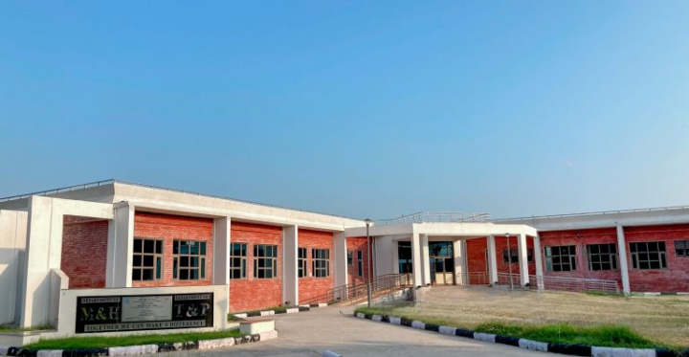](http://tnp.sliet.ac.in/files/2022/11/Picsart_22-08-29_17-09-16-770-1-768x398_clipdrop-cleanup.png)

**ABOUT SLIET :**

**Greetings from SLIET Longowal!**

Sant Longowal Institute of Engineering and Technology (SLIET), Longowal, was established by the Ministry of Human Resource and Development, Government of India in the year 1989. Since then, marching ahead, recently SLIET, achieved **56th Rank in the year 2016 by NIRF-MHRD-GOI.**

Today the Institute enjoys its status at par with NITs, IIMs, Central Universities, and other CFTIs. SLIET offers six Master’s Programs in Engineering courses, nine Bachelor’s Programs in Engineering courses, ten Integrated Certificate-Diploma (ICD) courses in addition to Ph.D. courses in various disciplines.

The Degree courses offered are in Computer Science and Engineering, Electronics & Communication Engineering, Instrumentation, and Control Engineering, Chemical Engineering, Mechanical Engineering, and Food Engineering & Technology. Our Engineering graduates spend 3 years after their diploma, 4 years after 10+2, and 6 years after matriculation in the institute to acquire technical knowledge which provides them with a technical edge over others.

**Under the Degree courses institution also offers some specialization courses such as:**

**Computer Science and Engineering:** IoT, Data Analytics, Optimization Techniques, Cryptography and Network Security

**Electrical Engineering:**Generalized theory of Electrical Machine, Distributed Generation & Smart Grid, Power System Operation & Control

**Instrumentation and Control Engineering:** Advance Sensors, Random and Stochastic Process

**Electronics and Communication Engineering:**AI Machine Learning, Electric Circuit Design

**Chemical Engineering:** Process Equipment Design, Optimization of Chemical Processes

**Mechanical Engineering:** Design of Welds, Inspection & Testing of Welds, Metallurgy, Non-Conventional Machining, Advance Manufacturing Process, and Tool Design.

**Food Engineering & Technology:**Agriculture, Enzyme, Realogy

Our alumni have been performing quite well in companies such as (but not limited to) **Google, Microsoft, TCS, ISGEC, GE India, Afcons Infra., Honda, L & T, Hero Group, Trident Group, Godrej, Vardhman Industries, Mahindra & Mahindra, Reliance, Infosys, Hewlett Packard, LG, Wipro, Honeywell,** Shell to name a few.

We at SLIET always strive to forge stronger relations with industries for mutual benefit through exchange programs, expert lectures by industry professionals, sharing of R&D facilities, consultancy, student projects, industrial training, etc.

[**Head of Department**](http://tnp.sliet.ac.in/head-of-department/)

[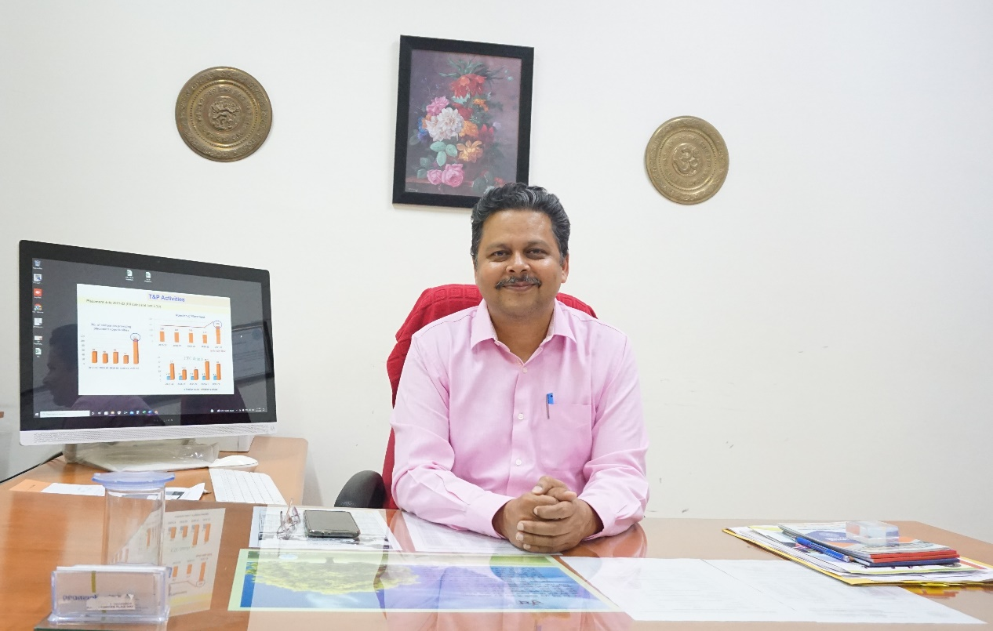](http://tnp.sliet.ac.in/files/2022/10/Dr.-Saxena-sir.jpg)

**Message from the Desk of HOD:**

*“I never teach my people, i only attempt to provide the condition in which they can learn.”****– Albert Einstein***

The challenge in today’s global and highly competitive markets are much high and one need to perform with utmost quality and professionalism. It gives me immense pleasure in stating that recently SLIET has achieved [56th rank](https://www.nirfindia.org/engg)for  best Engineering College in India by National Institutional Ranking Framework published by Ministry of Human Resource Development (MHRD) in April 2016.

We ensure that each student is given right industry exposure & skill development to meet the high-end corporate expectations. The T&P Department continuously look at job learning opportunities for students through live projects, research assignments, competitions, management games/ quizzes, industrial training, guest lectures, conferences, and seminars.

We also follow a stringent for Soft Skills Development & Corporate Communication which indeed is the utmost requisite to be in any industry. The dedicated team helps to bridge the gap for students between their campus and corporate life. It encompasses development of overall personality, communication skills, corporate etiquette and grooming while instilling right attitude towards leading and working in a team with professional ethics and time management skills. Projects are an integral part of the academic curriculum. The students are given opportunity to undergo Summer Internships with different organizations which provide them with basic understanding of the company’s operations; this ultimately enhances the adaptability of students at large & enables a student to evaluate his/her own interest in the company and thus identify an appropriate fit, both for summer internship and final placements.

SLIET is committed to offering good career opportunities to each student through excellent teaching and placement support. On behalf of the SLIET family, we invite each and every company and industry to visit our institute for campus recruitment and other purposeful academic activities of mutual interest.

**Dr. Ravindra K. Saxena  
Head,**Training and PlacementProfessor (Mechanical Engineering)  
Sant Longowal Institute of Engineering and Technology  
(Deemed-to-be-University, Under MoE, Government of India)  
Longowal-148106, Dist Sangrur, Punjab, INDIA

[](http://tnp.sliet.ac.in/files/2022/10/phone.jpg)+91 1672 253 133/134

[](http://tnp.sliet.ac.in/files/2022/10/Mobile.jpg)+91 92162 20006

[](http://tnp.sliet.ac.in/files/2022/10/mail.jpg)[headtp@sliet.ac.in](mailto:headtp@sliet.ac.in)

[](http://tnp.sliet.ac.in/files/2022/10/mail.jpg)[tnpoffice@sliet.ac.in](mailto:tnpoffice@sliet.ac.in)

[](http://tnp.sliet.ac.in/files/2022/10/mail.jpg)[tnpoffice16@gmail.com](mailto:tnpoffice16@gmail.com)

[](http://tnp.sliet.ac.in/files/2022/10/website.png)<http://tnp.sliet.ac.in/>

**Headship Department of Training and Placement**

|  |  |  |
| --- | --- | --- |
| **S. No** | **Name of Faculty** | **Department** |
| 1. | Dr. R.K. Saxena | ME |
| 2. | Dr. Ravi Kant Mishra | Maths |
| 3. | Dr. JapPreet Kaur Bhangu | M&H |
| 4. | Dr. Pradeep Kumar Jain | M&H |
| 5. | Dr. Pradeep Gupta | ME |
| 6. | Dr. N.P. Singh | Physics |
| 7. | Dr. J.S. Dhilon | EIE |

## [Placement Brochure](http://tnp.sliet.ac.in/placement-brochure/)

[**Click here to download the Placement Brochure 2022-23**](http://tnp.sliet.ac.in/files/2022/10/Placement-Brochure_compressed.pdf)

[**Click here to download the Placement Brochure 2021-22**](http://tnp.sliet.ac.in/files/2022/10/Placement-Brochure-2021-2022.pdf)

[**Click here to download the Placement Brochure 2018-19**](http://tnp.sliet.ac.in/files/2018/08/PB-min.pdf)

[**Click here to download the Placement Brochure 2017-18**](http://tnp.sliet.ac.in/files/2018/02/Placement-Brochure2017-18.pdf)

## [Placement Record](http://tnp.sliet.ac.in/placement/placement-record/)

### [****Placement Record of Departments 2016-2022 as per NAAC****](http://tnp.sliet.ac.in/files/2022/10/5-year-Placement-Record-for-NAAC-2016-17-to-2021-22-UG-PG.xlsx)

[**Placement Record of Departments 2016-22 as per NAAC Updated on Dated: 02/02/23**](http://tnp.sliet.ac.in/files/2023/02/5-year-Placement-Record-for-NAAC-2016-17-to-2021-22-UG-PG.xlsx)

[**Placement Record 2021-22**](http://tnp.sliet.ac.in/files/2022/11/Placement-record-2021-22.pdf)

[**Placement Record 2020-21**](http://tnp.sliet.ac.in/files/2022/11/Placement-record-2020-21.pdf)

[**Placement Record 2019-20**](http://tnp.sliet.ac.in/files/2022/11/Placement-record-2019-2020-2.pdf)

[**Placement Record 2018-19**](http://tnp.sliet.ac.in/files/2019/08/Placement-record-2018-19.pdf)

[**Placement Record 2017-18**](http://tnp.sliet.ac.in/files/2019/09/PLACEMENT-STATUS-2017-2018.pdf)

[**Placement Record 2016-17**](http://tnp.sliet.ac.in/files/2018/07/Placement-record-2016-2017.pdf)

[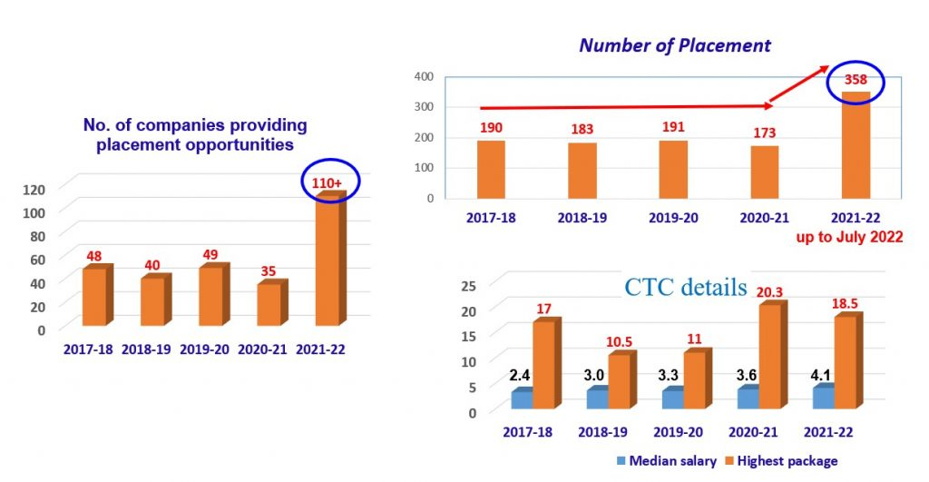](http://tnp.sliet.ac.in/files/2022/10/Placement-Record-1.jpg)

##### **Few smiling faces of 2020-2022**

[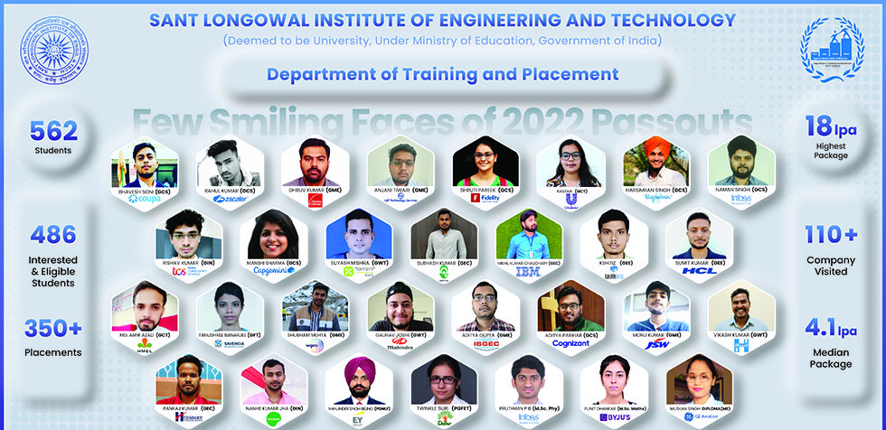](http://tnp.sliet.ac.in/files/2022/10/LnT2022.jpg)

##### **Few smiling faces of 2016-2020**

[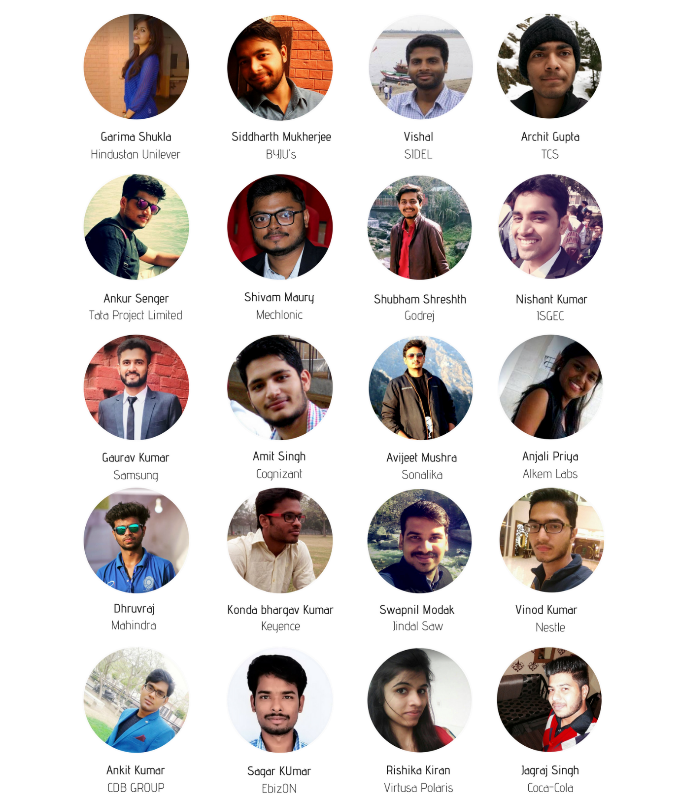](http://tnp.sliet.ac.in/files/2018/07/SAMSUNG-21.png)[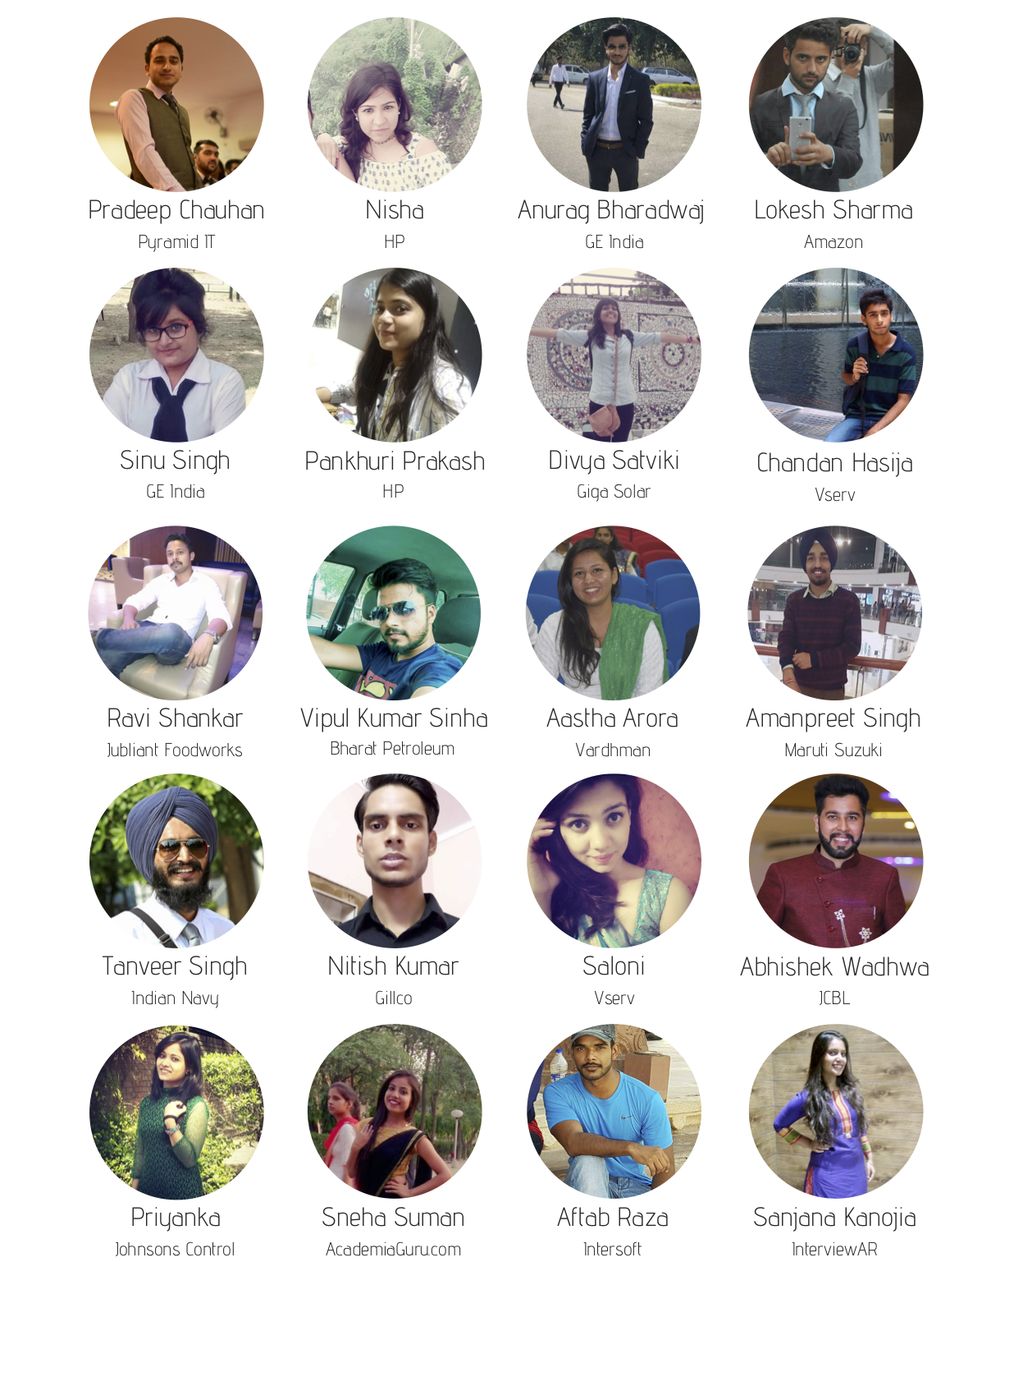](http://tnp.sliet.ac.in/files/2018/07/121.png)

[**Our Recruiters**](http://tnp.sliet.ac.in/our-recruiters/)

[](http://tnp.sliet.ac.in/files/2022/10/amazon-e1665577261487.png)

[](http://tnp.sliet.ac.in/files/2022/10/google.png)

[](http://tnp.sliet.ac.in/files/2022/10/microsoft.png)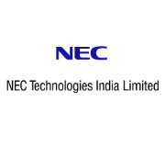

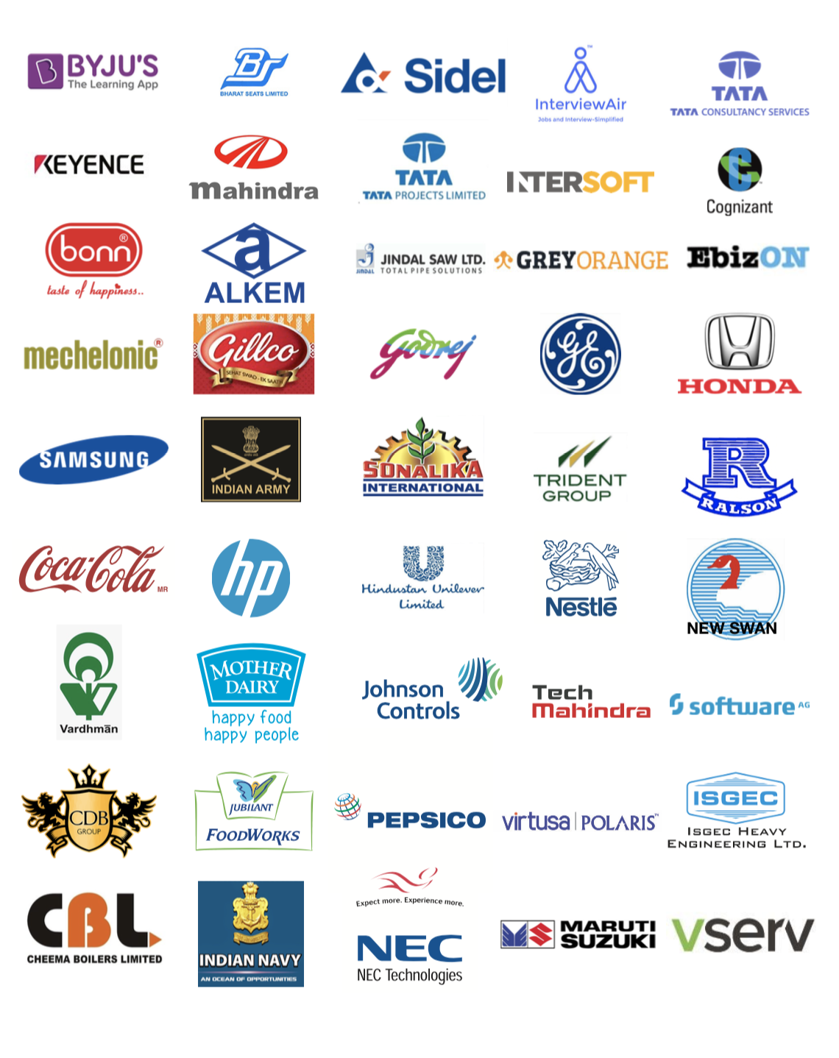

## [Officers & Staff](http://tnp.sliet.ac.in/officers-staff/)

# [Head of Department](http://tnp.sliet.ac.in/head-of-department/)

[](http://tnp.sliet.ac.in/files/2022/10/Dr.-Saxena-sir.jpg)

Dr. Ravindra K. Saxena  
Professor (Mechanical Engineering)  
Head, Training and Placement  
Sant Longowal Institute of Engineering and Technology  
(Deemed-to-be-University, Under MoE, Government of India)  
Longowal-148106, Dist Sangrur, Punjab, INDIA

[](http://tnp.sliet.ac.in/files/2022/10/phone.jpg)+91 1672 253 133, 134,

[](http://tnp.sliet.ac.in/files/2022/10/Mobile.jpg)+91 92162 20006

**[](http://tnp.sliet.ac.in/files/2022/10/mail.jpg)**[**headtp@sliet.ac.in**](mailto:headtp@sliet.ac.in)

[](http://tnp.sliet.ac.in/files/2022/10/mail.jpg)[tnpoffice16@gmail.com](mailto:tnpoffice16@gmail.com)

## ****Training and Placement Officer’s (TPO)****

[](http://tnp.sliet.ac.in/files/2022/10/dr.-major.jpg)

**Dr. Major Singh, TPO-I (For the department of CSE, ECE, EIE and  M&H)**

Phone No. : 01672-253133 – 134 & 01672-280021  
Mobile No. : 94174-30477  
Email Id : mjrsingh@yahoo.com

[Visit Full Profile](http://cs.sliet.ac.in/people/major/)

**[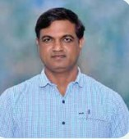](http://tnp.sliet.ac.in/files/2022/10/indraj-sir.jpg)**

**Dr. Indraj Singh, TPO-II (For the department of ME, FET, CE and  Civil)**

Phone No. : 01672-253133 – 134 & 01672-280021  
Mobile No. : 94174-60331  
Email Id : indrajsliet@yahoo.com

[Visit Full Profile](http://mech.sliet.ac.in/people/indraj/)

**[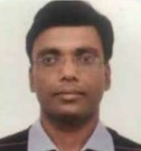](http://tnp.sliet.ac.in/files/2022/10/aswini-sir.jpg)**

**Dr. Ashwani Kumar Aggarwal, TPO-III**

Phone No. : 01672-253133 – 134 & 01672-280021  
Mobile No. : 95305-30190  
Email Id : ashwani.ist@gmail.com

[Visit Full Profile](http://eie.sliet.ac.in/people/ashwanikaggarwal/)

**[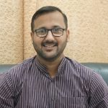](http://tnp.sliet.ac.in/files/2022/10/navneet-sir.jpg)**

**Mr. Navneet Goyal(AP)**

Mobile No. : 9779488600  
Email Id : navneetgoyal@sliet.ac.in

**[](http://tnp.sliet.ac.in/files/2022/10/neha-mam.jpg)**

**Miss Neha Gupta(ATPO)**

Mobile No. : 9805657556  
Email Id : nehagupta@sliet.ac.in

## Office Staff

**[](http://tnp.sliet.ac.in/files/2022/10/salim-sir.jpeg)**

**Mr. Saleem Khan**

Phone No. : 01672-253134  
Mobile No. : 94648-75867  
Email Id : tnpoffice@sliet.ac.in

**[](http://tnp.sliet.ac.in/files/2022/10/Gurjant.jpeg)**

**Mr. Gurjant Singh**

Phone No. – 01672-253134  
Mobile No. – 94655-24513

([viagrageneric.org](https://www.viagrageneric.org/viagra-50mg-dosage-how-to-buy-online-reviews/))

[**T&P Events**](http://tnp.sliet.ac.in/tnp-activities/)

**DEPARTMENT  ACTIVITIES/FUNCTIONS**

[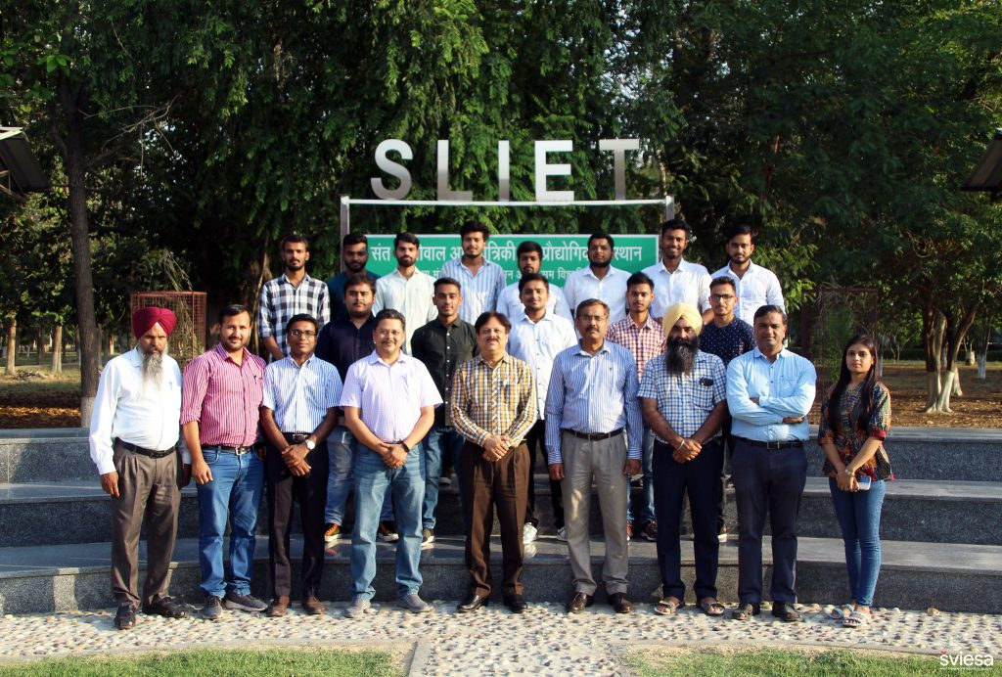](http://tnp.sliet.ac.in/files/2022/10/SPR_Photo_Final_Year.jpg)

We ensure that each student is given the right industry exposure & skill development to meet high-end corporate expectations. The T&P Department continuously looks at job learning opportunities for students through live projects, research assignments, competitions, management games/ quizzes, industrial training, guest lectures, conferences, and seminars.

We also follow a stringent for Soft Skills Development & Corporate Communication which indeed is the utmost requirement to be in any industry. The dedicated team helps to bridge the gap for students between their campus and corporate life. It encompasses the development of overall personality, communication skills, corporate etiquette, and grooming while instilling the right attitude towards leading and working in a team with professional ethics and time management skills. Below are some of the activities which are organized by T&P.

**List of activities conducted by the Department of Training and Placement:-**

1. **Campus Placement Activities**
2. **Mock Interviews**
3. **Campus to Corporate Activities**
4. **Recruiters Connect**
5. **Dialog with our Pride Alumni**
6. **Share the Baton**
7. **e-HRAC-2020**
8. **Career Fair**
9. **Career Counselling**
10. **Expert Talk from Industry People**
11. **Webinar on NEP2020**
12. **Entrepreneurship Development Program**

**Some Highlighted Activities which is being conducted by T&P Department are:-**

1. **Pre-Placement Talk**: The Pre-Placement Talk is an opportunity for  SLIETIANS to meet prospective companies and discuss their own interests and requirements for the placement. It is a kind of Presentation held by the company for the candidates, followed by Q&A session. It is also the chance for you to learn about the agency and what it might be like doing a placement there.

**Topics Covered under PPT**

|  |  |  |
| --- | --- | --- |
| 1. Companies  Domain | 2. Companies History | 3. Why join them |
| 4. Selection Procedure | 5. Their Uniqueness |  |

|  |  |
| --- | --- |
|  |  |

**2. Campus to Corporate**:  It is a state of transition from being a student to becoming a professional. Placed students of our college interact with their senior colleagues, and faculty make a crisp presentation and develop habits that can help them stand out. Life skills and business skills are seamlessly woven into the program that softens the landing into the challenging corporate world. This program is organized in our college every year for placed students to give them accomplishment. We called this annual program by the name “UDAAN”. As per the tradition of the department since 2016 the department of Training and Placement, SLIET has conducted successfully the annual event “UDAAN”(Campus to Corporate) & distributed the offer of appointment to our class 2020 students.

**Here are some glimpses of “UDAAN” 2020:**

|  |  |  |
| --- | --- | --- |
|  |  |  |

**3.Placement Preparation Program: The**Training and Placement department of SLIET is organizing the “Placement Preparation Program” for undergraduate students mostly for pre-final years. It will be going to benefit them in their future upliftment placement endeavour. The main objective of this program is to ensure uniform placement for each section of students. We stand up to the students by enhancing their Aptitude ability,  communication skills, group discussion, and overall personality development and by taking session which provides them with proper information and guidance.

**Mainly four programs are covered under this:**

1. **Share the “BATON”:** It is an alumni student program where alumni of SLIET are going to share their experience of the industry and the workplace. Students clear their all doubts regarding the corporate world through this program.  They get to know all the points which can become barriers for their desired company. Alumni share their own good and bad experience which become a true lesson for our students.

|  |  |
| --- | --- |
|  |  |

2. **Aptitude Test:** Aptitude Test Series is a topic-wise test designed to help the pre-final year students of Sant Longowal Institute of Engineering and Technology to be more prepared and competent for their placement processes. Most prestigious companies like TCS, Infosys, Maruti, L&T, Orient, etc. conduct Aptitude Tests as their first round of selection. The training and Placement Department is conducting Aptitude Tests for the pre-final year students. Your score is marked and used for placement purposes in the future.

|  |  |
| --- | --- |
|  |  |

|  |
| --- |
|  |

1. **Seminars:** Seminars are organized for a day or a couple of days, with the aim of bringing together subject experts and industry professionals to share expertise and ideas. Seminars help you to improve your knowledge and enhance your skill. The “TRAINING AND PLACEMENT DEPARTMENT” of Sant Longowal Institute of Engineering and Technology (SLIET) is glad to announce that we are going to conduct seminars for the UG-2020 batch students. This will lead to higher productivity and fulfillment of their goals.  
   ​

|  |  |
| --- | --- |
|  |  |

1. **GDPI:** Group Discussion (GD) assesses the overall personality – thoughts, feelings, and behavior – of an individual in a group. A topic is presented to the group members for discussion. While the discussion is going on, a group of panelists observes them. Through this observation, they judge the intellectual, social, leadership, and communicative skills of candidates taking part in the GD

|  |  |
| --- | --- |
|  |  |

[**For more detail regarding Placement Preparation Program, click here**](http://tnp.sliet.ac.in/files/2022/10/Placement-preparation-program-Notice-with-annexure.-.pdf)

**3. Career Counselling:**In the career counseling process, our focus is set on assisting individuals to better understand themselves as well as current workplace trends, to facilitate informed career and educational decision-making by them. Overall, career counselors provide guidance and support to candidates at every step of their job search and make them confident to gain an edge over the competition.

Career counseling helps develop a wide range of skills such as:

– Better concentration  
– Improved time management  
– Conflict handling  
– Collaboration  
– Communication skills

**4.Mock Interviews :** Mock interview is like a simulation of an actual job interview. It provides our students with an opportunity to practice for an interview and receive feedback on their interviewing skills. The mock interviews are conducted as a practice job interview held with a professional career counselor. A mock interview helps our students to learn how to answer difficult questions, develop interview strategies, improve communication skills, and reduce stress before an actual job interview.

**For more Detail T&P activities, please click here:** [T&P Activities](http://tnp.sliet.ac.in/tnp-activities/tp-activities-4/)

[**SLIET Alumni Assosiation**](http://tnp.sliet.ac.in/alumni/sliet-alumni-assosiation/)

**About Alumni Association**

Established in 2015, SLIET Alumni Association creates and maintains a lifelong connection between the institute and its alumni. In collaboration with an extremely dedicated volunteer board of directors, the Alumni association works to connect alumni, support students, and build an unforgettable experience through a diversity of events, programming, and services. The association aims to encourage the alumni to take an abiding interest in the progress and development of the institute. Since its establishment, the association has grown from strength to strength, regularly undertaking several initiatives to promote and foster mutually beneficial interaction between the alumni and Alma Mater.

**Vision and Priorities**

The mission of the association is to foster a strong bond between alumni, students, and the institute, to keep alumni informed, and create a network enabling them to remain engaged with their Alma Mater and help shape its future through the Association’s programmes and services.

**Become a life member**

Anyone who has completed one academic year as a student of SLIET is eligible for life membership.

**SLIET Alumni Constitution:**

The written constitution is [available online.](https://slietalumni.in/constitution)

**Involvement and Services**

Developing an active and engaged alumni network empowers both the institute and its graduates. The Alumni association continues to seek innovative ways to serve alumni by providing social, educational, and professional opportunities that appeal to our broad constituency. Our alumni association offers:-

* Alumni career and networking services.
* Lifelong learning.
* Student alumni contact.
* Ongoing benefits.
* Events and reunions.
* Geo graphically alumni chapters.
* Travel
* Events and reunions.
* Geo graphically alumni chapters.
* Travel
* Replenish
* Support your hostel
* Support your country

## [Our Alumni](http://tnp.sliet.ac.in/alumni/our-alumni/)

### Our Alumni

Please check the complete list : [Alumni details](http://14.139.242.71:8079/Alumni/SlietAlumni.aspx) <a>[http://14.139.242.71:8079/Alumni/SlietAlumni.aspx<a/](http://14.139.242.71:8079/Alumni/SlietAlumni.aspx%3ca/)>

## [Contact Us-Alumni](http://tnp.sliet.ac.in/alumni/contact-us-alumni/)

Contact Us-Alumni: [Please fill the form.](https://slietalumni.in/contact-us)

<a>[https://slietalumni.in/contact-us</a](https://slietalumni.in/contact-us%3c/a)>

## [Reach Us](http://tnp.sliet.ac.in/reach-us/)

**Sant Longowal Institute of Engineering and Technology**

[](http://tnp.sliet.ac.in/files/2022/10/location.png)Department of Training and Placement, SLIET Campus, Sangrur, Punjab-148106.

[](http://tnp.sliet.ac.in/files/2022/10/phone.jpg)01672-253133 / 134

**Training and Placement Office:**

[](http://tnp.sliet.ac.in/files/2022/10/mail.jpg)[headtp@sliet.ac.in](mailto:headtp@sliet.ac.in)

[](http://tnp.sliet.ac.in/files/2022/10/mail.jpg)[tnpoffice@sliet.ac.in](mailto:tnpoffice@sliet.ac.in)

[](http://tnp.sliet.ac.in/files/2022/10/phone.jpg)01672-253134/133

**Follow Us on:**

[](http://tnp.sliet.ac.in/files/2022/10/linked-in.png)[/slietofficialtnp](https://www.linkedin.com/company/slietofficialtnp/?miniCompanyUrn=urn%3Ali%3Afs_miniCompany%3A75632569)

[/SLIET](https://t.me/SLIET)

[/slietofficialtnp](https://www.facebook.com/slietofficialtnp/)

instagram-Logo-PNG-Transparent-Background-download - 180 Degrees Consulting[/slietofficialtnp](https://instagram.com/slietofficialtnp?igshid=YmMyMTA2M2Y=)